Project Design Phase-II Technology Stack (Architecture & Stack)

|  |  |
| --- | --- |
| Date | 15 October 2022 |
| Team ID | PNT2022TMID35942 |
| Project Name | Project - AI based discourse for Banking Industry |
| Maximum Marks | 4 Marks |

Technical Architecture:

The Deliverable shall include the architectural diagram as below and the information as per the table1 & table 2

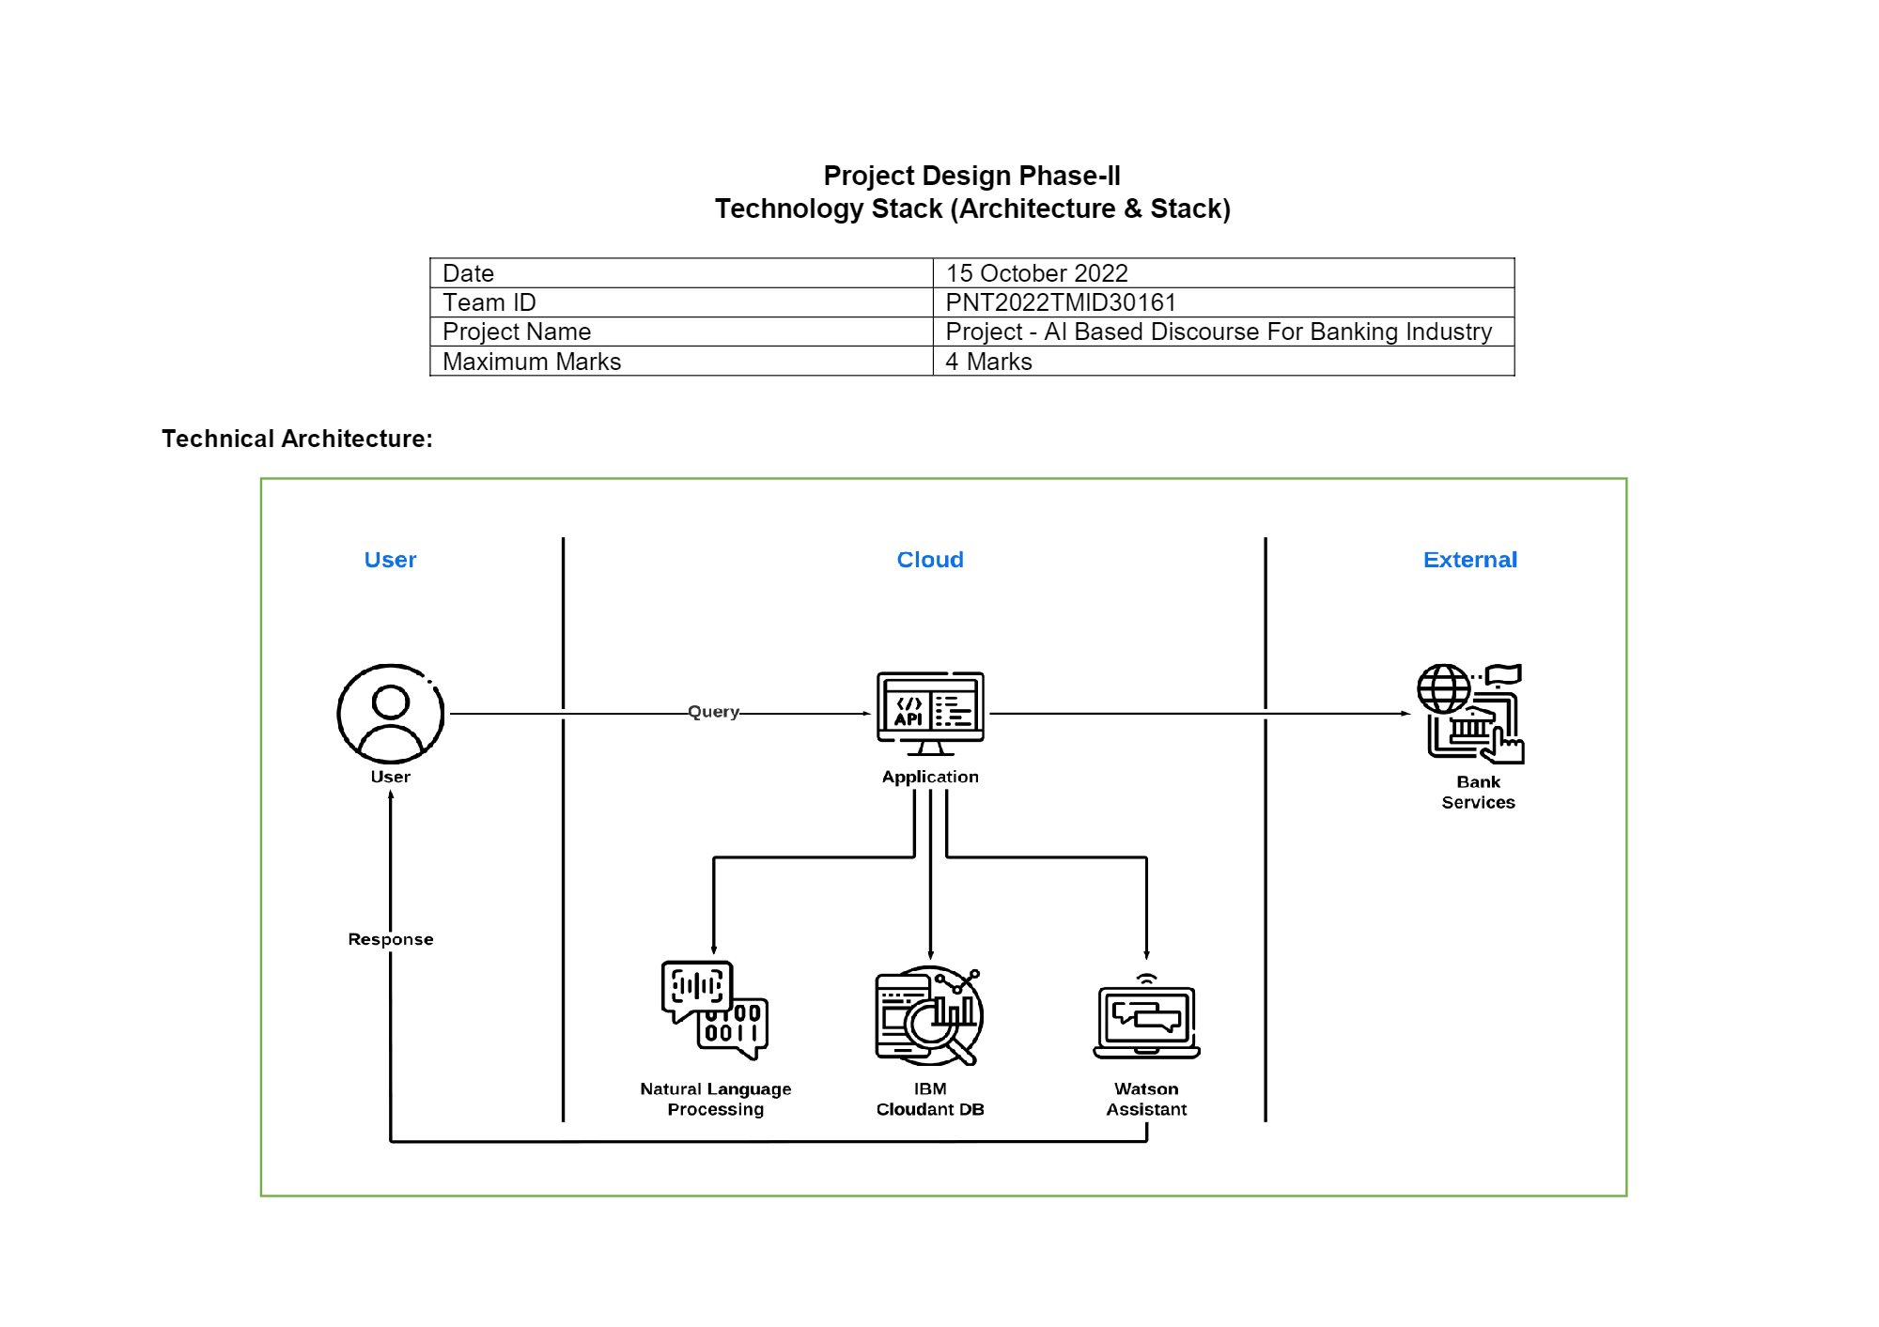

Table-1: Components & Technologies:

|  |  |  |  |
| --- | --- | --- | --- |
| **S. No** | **Component** | **Description** | **Technology** |
| 1. | User Interface | User interacts with the system through the Chatbot | Python / Flask |
| 2. | Application Logic-1 | System is trained with queries and answers for Net Banking actions, account creation. | IBM Watson Assistant |
| 3. | Application Logic-2 | System is trained with queries and answers for Loan actions, general queries. | IBM Watson Assistant |
| 4. | Application Logic-3 | System is trained with queries and answers for Savings account actions | IBM Watson Assistant |
| 5. | Cloud Database | Database Service on Cloud | IBM DB2, IBM Cloudant. |
| 6. | External API-1 | API supports Artificial Intelligence to support super intelligent bots. | Flask |
| 7. | Deep Learning Model | Deep learning model can be used for Natural Language Processing | Natural Language Processing |
| 8. | Infrastructure (Server / Cloud) | We will deploy the AI model on the cloud server using Flask in the webpage | Python Flask |

Table-2: Application Characteristics:

|  |  |  |  |
| --- | --- | --- | --- |
| **S. No** | **Characteristics** | **Description** | **Technology** |
| 1. | Open-Source Frameworks | IBM Watson, Google collab, Anaconda, Flask | Python, Flask, Deep learning, IBM Watson |
| 2. | Security Implementations | IBM Cloud | Certified IBM Watson for encrypted file  systems, Encrypted storage systems, Key management systems |
| 3. | Scalable Architecture | The proposed model can be updated based on the demands and suggestions of the customers.  System can be trained with new queries whenever required. | IBM Watson Assistant |
| 4. | Availability | The AI Chatbot is made available to the users at any point of time | IBM Watson Assistant |
| 5. | Performance | The system can be trained for Loan actions, savings account actions, general queries, net  banking queries in the most efficient way along with Natural Language Processing. | IBM Watson Assistant |

References:

<https://c4model.com/>

<https://developer.ibm.com/patterns/online-order-processing-system-during-pandemic/> <https://www.ibm.com/cloud/architecture>

<https://aws.amazon.com/architecture>

<https://medium.com/the-internal-startup/how-to-draw-useful-technical-architecture-diagrams-2d20c9fda90d>